Sri Lanka Institute of Information

Technology



Lab Submission

<Lab sheet No 09>

**IT24102372**

**Wijesinghe D.H.R.**

**Probability and Statistics | IT2120**

B.Sc. (Hons) in Information Technology

**Exercise**

**(1)**



**(i)**

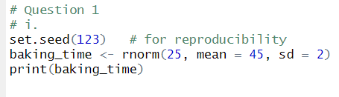

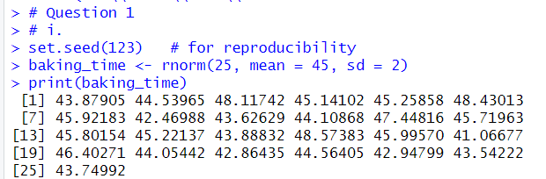

**(ii)**

